Theoretical Exam CPS-322 Pharmaceutical Biotechnology
17 December 2015, 13:30-16:30 hrs RUPPERT 042

Please answer the questions as concise as possible and within the allocated space. In case you made a mistake, clearly strikethrough the wrong text. Use the back of the paper sheet in case you need more space but clearly indicate you did so. Write your name and student number on each page. If you have all answers correct you will get 100 points. The final grade will be # points/10. Good luck!

- Which of the following restriction enzymes generate compatible sticky ends? (5 pts)
VneI (G/TGCAC), NsiI (ATGCA/T) and SdaI (CCTGCA/GG)
- VneI and NsiI
- VneI and SdaI
- NsiI and SdaI
- All three
Het juiste antwoord is c.

- Draw a plasmid vector map for the recombinant production of human acid alpha glucosidase (GAA) under control of an SV40 promotor in CHO cells. Include all necessary elements for expression of rhGAA and selection markers to generate stable cell lines. (10 pts)

Full points indien aanwezig zijn en in juiste oriëntatie/volgorde:
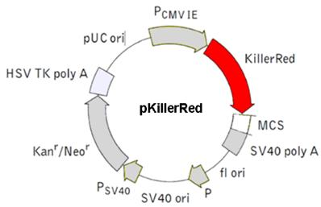
- SV40 promoter
- Start codon
- GAA sequence
- Poly adenylation signal
- Origin of replication
- Promoter voor resistance marker
- Kana/Neo resistance marker
- Poly adenylation signal voor resistance marker
Punt eraf voor ieder missend onderdeel of verkeerde volgorde/oriëntatie

Optioneel:
- Intron splice site
- Multiple cloning site
- Kozak sequence

- Betaseron and Avonex are both biopharmaceuticals used to reduce the number of relapses in people with relapsing form of multiple sclerosis. Betaseron consists of recombinant human interferon beta-1b (produced in bacteria) and Avonex of recombinant human interferon beta-1a (produced in CHO cells). Avonex is given at a dose of 30 mcg IM qWk and Betaseron is given at a dose of 250 mcg SC every other day.
- How can the differences in dose be explained? (3 pts)
Multiple options (in order of likeliness):
- Specific activity of Betaseron is less due to lack of glycosylation or improper folding (3pts)
- Different route of administration gives different bioavailabilities (2 pts)

- Which of these products is most likely more immunogenic? Explain why? (3 pts)
Betaseron again for several reasons:
Lack of glycosylation which may expose immunogenic epitopes
Change of a single aa as compared to the native interferon
More frequent dosing at higher concentrations
Improper folding, which may cause aggregation

- What do QALY and ICER stand for? Explain why these terms are being used for biopharmaceuticals? (4 pts)

Deze vraag komt te vervallen omdat de studenten dit college niet hebben gehad

- Nanobodies are single domain antibodies of approx. 12-15 kDa generated from the heavy chain antibodies found in camelids. They have a short plasma half-life of approx. 0.6 h.
  - What is the main reason for such a short half-life of nanobodies as compared to human IgG antibodies? (3 pts)
Glomerular filtration and renal clearance (glomerular filtration cut off is ~60 kD)
  - Name at least 3 engineering strategies by which the plasma half-life of nanobodies could be improved. (6 pts)
- XTEN technology
- PEGylation
- IgG Fc fusion contructs
- Turn into full antibody
- Albumin binding
- HESylation

- Indicate for the techniques below how they work and what you can do with it in terms of protein characterization. (1 pt each)

- Mass spectrometry Mass spectrometry works by ionizing chemical compounds to generate charged molecules or molecule fragments and measuring their mass-to-charge ratios. Can be used to determine aa sequence of proteins (MS_MS), mass of intact proteins, or positions of glycosylations within proteins
- HPLC High performance liquid chromatography. Separation based on size/charge/hydrophobicity
- Hydrophobic interaction chromatography Separate proteins based on exposed hydrophobic residues
- Dynamic light scattering measure hydrodynamic radius of proteins and aggregates
- Fluorescence spectroscopy quantification of proteins based on intrinsic fluorescence properties or by using extrinsic labels (fluorescent antibodies). Can also be used to obtain structural information of proteins.

- Mention 2 different ways by which fully human monoclonal antibodies against a human protein can be obtained. Explain shortly how each of these techniques work (8 pts)

Transgenic mice that produce fully human antibodies. mAb can be obtained by the classical vaccination/hybridoma technology

Phage display or other display technique based on native human loci. mAb can be obtained by iterative rounds of panning against a purified antigen

- What are the roles of CBER and CDER within the FDA? (2 pts)

CDER overseeing the development and marketing approval of chemical drugs and well characterized biological drugs. CBER of complex biological drugs (biologics), including vaccines, gene therapy products, antitoxins etc. etc.

What is the European counterpart of the CDER? (2 pts)
The European Medicines Agency

Which of the following products is/are NOT regulated by the CBER? (3 pts)
  - Vaccines
  - Thrombolytic agents
  - Gene Therapy Products
  - Antitoxins
  - Monoclonal Antibodies
See table 4.8 Gary Walsh. Thrombolytic agents and monoclonal antibodies is the right answer
- List at least 5 different mechanisms by which proteins can lose their function during storage in liquid form in the fridge? (5 pts)
Denaturation
Subunit dissociation
(partial)unfolding
Aggregation
Oxidation deamidation
Aggregation
Enzymatic degradation/proteolysis

- Which technique(s) can be used to determine a change in protein structure upon storage? (4 pts)
  - Polyacrylamide gel electrophoresis (SDS-PAGE)
  - Mass Spectrometry (MS)
  - Circular Dichroism Spectroscopy (CD)
  - Nuclear Magnetic Resonance Spectroscopy (NMR)
B,C and D are all possible techniques for this. 4 pts if all three were selected. 3 pts if 2 correct techniques were selected. 1 pnt if only one correct technique was selected
- Which technique(s) can be used to determine changes in the glycosylation pattern of mAbs? (4 pts)
  - Isoelectric focusing (IEF)
  - Anion Exchange Chromatography (AEX)
  - Circular Dichroism Specroscopy (CD)
  - Polymerase Chain Reaction (PCR)
A and B

- Describe the differences between transcription and translation in prokaryotes and (higher) eukaryotes. Also indicate in which subcellular compartments these successive processes take place (4 pts)
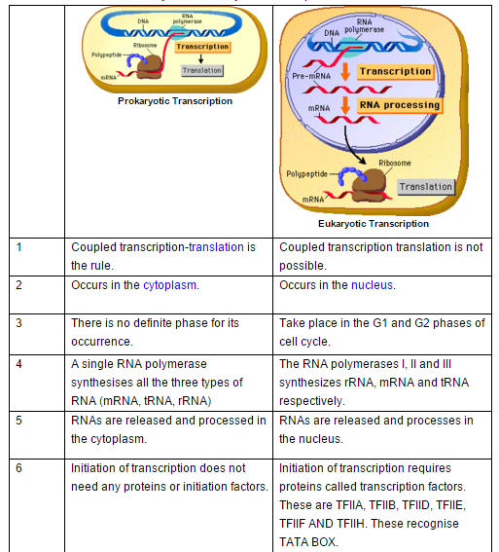

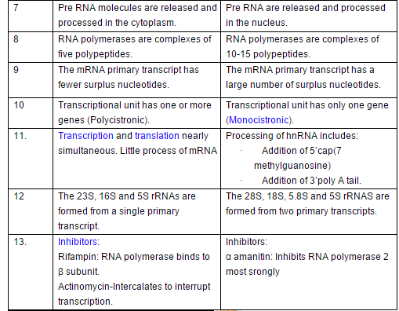

- a) Explain what is meant with “drug substance”, “drug product” and “excipients”? (3 pts)

drug substance: the pharmacologically active molecule (protein)
Drug product: the entire formulation, including excipients
Excipients: substances to increase the stability of the drug substance that by itself are not active.

b) What is the role of the following excipients in a drug product? (4 pts)
- Mannitol bulking agent used for freeze drying. Protein stabilizer
- Polysorbate stabilizes proteins at low concentrations by preventing protein aggregation at interphases (air-liquid or liquid-glass)
- Arginine Protein stabilization. They appear to exert their stabilizing influence by various means, including reducing surface adsorption of product, inhibiting aggregate formation, and directly stabilizing the conformation of some proteins.
- Benzyl alcohol preservative

- Dornase alfa (Pulmozyme) is a biosynthetic form of human deoxyribunuclease I (DNase I) enzyme. It is produced in genetically modified Chinese hamster ovary (CHO) cells using recombinant DNA technology. The 260-amino acid sequence of dornase alfa is identical to the endogenous human enzyme. Dornase alfa cleaves extracellular DNA to 5´-phosphodinucleotide and 5´-phosphooligonucleotide end products. Dornase alfa has a melting point at 67 °C and an isoelectric point (pI) of 4.58
  - What is the main reason why this enzyme was produced in CHO cells and not in bacteria like E. coli? (3 pts)
Toxic to bacteria as it breaks down DNA and is produced in the same compartment as where the DNA is located

  - Design a strategy how to purify this recombinant enzyme from the culture medium of CHO cells? Describe the successive purification/concentration steps and indicate for each step what it will remove (if any). (7 pts)

Multiple options are possible. The students could make use of a relatively high melting point to partially purify the protein by heat exposure. Given the pI the protein will have a negative charge at neutral pH, which could be used in anion exchange chromatography.
Purification steps should include:
- Clearance step. Removal of cellular debris from culture medium by TFF/crossflow filtration or centrifugation (latter is not logical given the enormous volumes, although continuous flow centrifugation could be used)
- Concentration step by diafiltration/ultrafiltration
- Capture step, mostly affinity chromatography. A DNA-based ligand could be used for this to which the protein binds but does not convert. Alternatively, antibodies could be used.
- 2nd separation step. Could be anion exchange to separate the protein from host nucleic acids and other anionic proteins
- 3rd separation step. Size exclusion chromatography, Hydrophibic interaction chromatography or any other separation technique that is not based on charge as in step 2.
- Optionally, desalting/buffer exchange

15). Absence of protein Y results in a life-threatening disorder which can only be treated by protein replacement therapy. Currently, there are 2 recombinant products on the market, one derived from expression by prokaryotic (E. coli) and one derived from expression by eukaryotic (CHO) cells. In both cases, 20-25% of the patients develop inhibitory antibodies. The price of these biopharmaceuticals are dictated by the high production costs and frequency of dosing (twice weekly subcutaneous injections). A third pharmaceutical company wants to first enter the market with a biosimilar, while at the same time investing in R&D to develop a second-generation product.

a). Name at least one strategy how you could make a cheaper biosimilar as compared to the originator (2 pts)
Cheaper means either cheaper production costs or less frequent dosing. Any strategy that can achieve this without changing the active drug substance is a good strategy.
Cheaper biosimilar
-codon optimization

b). Name a strategy how you could make a product-plus that is less immunogenic (2 pts)

Product-plus biosimilar
-completely human production process (HEK cells opposed to CHO or bacteria)
-less immunogenicity

16). Therapeutic monoclonal antibodies are nowadays engineered to be less immunogenic than the first (mouse) monoclonal antibody that was used in the clinic.
- Explain how a 'humanized' therapeutic monoclonal antibody differs from a mouse monoclonal antibody (2 pts)
Humanized: CDRs from murine mAbs are grafted onto a human IgG backbone to obtain the desired specificity.

- Which of the following types of antibodies do you expect will be (predominantly) formed against the therapeutic human anti-TNF antibody adalimumab and why: anti-idiotype, anti-allotype, anti-isotype? (2 pts)
Anti-idiotype. CDRs are the only potential non-self regions

In practice, the majority (>60%) of rheumatoid arthritis patients treated with adalimumab develop antibodies to this drug. Nevertheless, the drug is still effective in a large portion of the patients (ca 70%).
- Explain how this is possible (2 pts)
Binding antibodies instead of neutralizing antibodies
Neutralizing antibodies can be saturated with higher dose

- If a patient initially responds well to adalimumab, but loses response to adalimumab because of immunogenicity, would you recommend to start treatment with infliximab, another anti-TNF antibody? Why (not)? (2 pts)
Yes, this is possible. Each mAb has different CDRs and therefore are neutralized by different antibodies.

